UNIVERSITY OF MINNESOTA
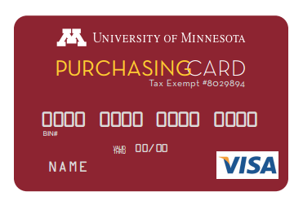 | Application for Student Use of Departmental  Procurement Card

Section I – Please fill out electronically
This section to be completed by Applicant

New cardholders must complete the PCard Cardholder Training: Using the University PCard online training before a new card can be ordered. Indicate the date the training was completed.

Employee ID #: | Internet ID: | Email Address:
Card Applicant Name: (Limit 23 Characters, including spaces) Employee ID #:
First Name MI (Optional) Last Name  Middle Initial (Optional) |  |  | Phone # (xxx-xxx-xxxx)
Cardholder Agreement: As a University of Minnesota Procurement Cardholder, I:
- Accept the responsibility for the protection and proper use of the card.
- Understand the card may be used only for authorized University business related purchases and no personal purchases are permitted.
- Understand any personal, improper or fraudulent charges on the card could be considered misappropriation of University funds and will result in immediate revocation of the card any may result in corrective action up to and including termination and/or criminal prosecution. In addition, the University will seek restitution for any inappropriate charges.
- Must report a lost/stolen card immediately.
- Understand the University may terminate the right to use the card at any time for any reason.
- Will not lend my card to others to use.
- Certify successful completion of the required online PCard training.
- Will ensure that the purchases made with this card are allowable for the type of funds used. (Refer to University policy and sponsoring agency regulations).
- Agree to assume personal liability for any unallowable activity and understand that the University of Minnesota may proceed to charge unauthorized charges and/or losses incurred by the University as a result of such activity to my Student account.
I have read and agree to all of the statements above. By signing this application, I acknowledge the responsibilities that accompany accepting the card and agree to comply with the University’s policies, procedures, applicable laws, and ethical practices when using the card.

Signature _____________________________________________ (Cardholder) Date ________

Departmental Approval

Print Name |  | (Dean, Department Head or Designee approval)
Signature |  | Date

